Davy Crockett Biography
U.S. Representative, Folk Hero (1786–1836)

Quick Facts
Name
Davy Crockett
Occupation
U.S. Representative, Folk Hero
Birth Date
August 17, 1786
Death Date
March 6, 1836
Place of Birth
Greene County, Tennessee
Place of Death
San Antonio, Texas
AKA
Davy Crockett
Colonel David Crockett
Nickname
King of the Wild Frontier
Full Name
David Crockett
- Synopsis
- Background and Early Life
- War of 1812
- U.S. Congressman
- Frontiersman and Folk Legend
- Death at the Alamo and Controversy
- Videos
- Cite This Page
Davy Crockett was a frontiersman, legendary folk hero and three-time Congressman. He fought in the War of 1812 and died at the Alamo in the Texas Revolution.

IN THESE GROUPS
- Famous People in U.S. Politics
- Famous People in Military History
- Famous People in Journalism & Nonfiction
- Famous Democrats
Show All Groups
- Famous Government
- Famous Leos
- Famous People Who Died in Texas
- Famous People in Politics & Government
- Famous People Born in United States
- Famous People Born in Greene County
- Famous People Who Served in the Military
- Famous Congressional Representatives
- Famous People Who Died in Military Battle
- Famous People Who Died on March 6
- Famous Military Veterans
- Famous People Who Held Political Office
- Famous People Born on August 17
- Famous People Born in 1786
- Famous People Named Davy
- Famous People Named Crockett
- Famous Folk Heroes
- Famous European Americans
- Famous People Born in Tennessee
- Famous People Who Died in United States
- Famous People Who Died in 1836
- Famous People Who Died in San Antonio
quotes
“I'm that same David Crockett, fresh from the backwoods, half-horse, half-alligator, a little touched with the snapping turtle; can wade the Mississippi, leap the Ohio, ride upon a streak of lightning, and slip without a scratch down a honey locust [tree].”
—Davy Crockett
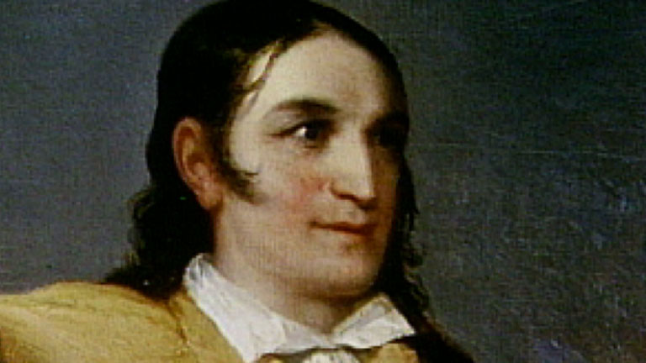
Davy Crockett - Remember Davy Crockett (TV-PG; 2:03) Davy Crockett biography on his exploration and interest of discovering Texas into his death at the Battle of the Alamo in 1836.

Synopsis
Davy Crockett was born on August 17, 1786, in Greene County, Tennessee. In 1813, he participated in a massacre against the Creek Indians at Tallushatchee and later earned a seat in the 21st U.S. Congress. He was reelected to Congress twice before leaving politics to fight in the Texas Revolution. On March 6, 1836, Crockett was killed at the Battle of the Alamo in San Antonio, though the exact circumstances of his death have been the subject of debate. The myth of Crockett was commodified for children during the 1950s as part of the popular Disneyland TV series.

Background and Early Life
Davy Crockett was born as David Crockett on August 17, 1786, in Greene County, Tennessee. He was the fifth of nine children born to parents John and Rebecca (Hawkins) Crockett.
Crockett's father taught him to shoot a rifle when he was just 8 years old. As a youngster, he eagerly accompanied his older brothers on hunting trips. But, when he turned 13, his father insisted that he enroll in school. After only a few days of attendance, Crockett fought the class bully and was afraid to go back lest he face punishment or revenge. Instead, he ran away from home and spent more than two years wandering while honing his skills as a woodsman.
Just before he turned 16, Crockett went home and helped work off his father's debt to a man named John Canady. After the debt was paid, he continued working for Canady. At just a day shy of 20, Crockett married Mary Finley. The two would have two sons and a daughter before Mary died. Crockett then wed Elizabeth Patton, with the couple having two children.

War of 1812
In 1813, after the War of 1812 broke out, Crockett signed up to be a scout in the militia under Major John Gibson. Stationed in Winchester, Tennessee, Crockett joined a mission to seek revenge for the Creek Indians' earlier attack on Fort Mims, Alabama. In November of that year, the militia massacred the Indians' town of Tallushatchee, Alabama.
When Crockett's enlistment period for the Creek Indian War was up, he reenlisted, this time as a third sergeant under Captain John Cowan. Crockett was discharged as a fourth sergeant in 1815 and went home to his family in Tennessee.

U.S. Congressman
Having returned home, Crockett became a member of the Tennessee State House of Representatives from 1821 to 1823. In 1825, he ran for the 19th U.S. Congress, but lost.
Running as a Jacksonian candidate in 1826, Crockett earned a seat in the 20th Congress. In March of 1829, he changed his political stance to anti-Jacksonian and was reelected to the 21st Congress, though he failed to garner a seat in the 22nd Congress. He was, however, elected to the 23rd Congress in 1833. Crockett's stint in Congress concluded in 1835, after his run for reelection to the 24th Congress ended in defeat.

Frontiersman and Folk Legend
During his political career, Crockett developed a reputation as a frontiersman that, while at times exaggerated, elevated him to folk legend status. While Crockett was indeed a skilled woodsman, his notability as a Herculean, rebellious, sharpshooting, tale-spinning and larger-than-life woodsman was at least partially a product of his efforts to package himself and win votes during his political campaigns. The strategy proved largely effective; his fame helped him defeat the incumbent candidate in his 1833 bid for reelection to Congress.

Death at the Alamo and Controversy
After Crockett lost the 1835 congressional election, he grew disillusioned with politics and decided to join the fight in the Texas War of Independence. On March 6, 1836, he was believed to be killed at the Battle of the Alamo in San Antonio, Texas. In a 1975 English translation, the memoirs of a Mexican officer named José Enrique de la Peña stated that Crockett and his comrades at arms were gruesomely executed, though they "died without complaining and without humiliating themselves before their torturers."
Yet questions over the memoir, which was first published in 1955, have risen over the years, with some scholars disagreeing over the veracity of the account of Crockett's death. Thus the exact circumstances of his demise at the Alamo remain the subject of debate.

Disney Depictions
Crockett has enjoyed ongoing depictions in various media forms over the decades. He was the subject of various books and almanacs along with a play during the 19th century. He later entered the popular imagination of the 20th century due to a 1916 movie and the 1950s Walt Disney TV series Disneyland, featuring actor Fess Parker as Crockett in a number of episodes. The show and accompanying big-screen film cemented the frontiersman as an icon for many children, also inspiring a merchandising bonanza while creating new sets of fictions for historians to contend with. Crockett received more screen time via John Wayne's portrayal in the 1960 film The Alamo.

Videos

Fact Check
We strive for accuracy and fairness. If you see something that doesn't look right, contact us!

Citation Information

Article Title
Davy Crockett Biography

Author
Biography.com Editors

Website Name
The Biography.com website

URL
http://www.biography.com/people/davy-crockett-9261693

Access Date
June 26, 2016

Publisher
A&E Television Networks

Original Published Date
n/a

